Computer Language Coding Concepts

Object Reference Assignment in a Diagram
The principle of object reference assignment is explained in the article Object Reference Assignment. This article demonstrates the expression of it in a diagram.

About the notation of assignment in general, see the article Assignment in a Diagram.

The difference in notation between a normal assignment and an object reference assignment is, that object reference assignment has an arrow displayed inside the assignment call, pointing in the direction of the object reference that is assignened.



Effect of Object Reference Assignment
Now the difference in effect between a normal assignment and an object reference assignment will be displayed.

The following situation is given:

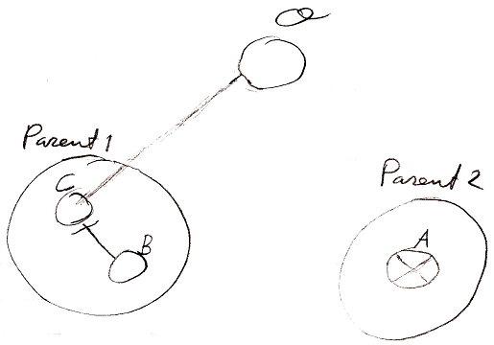

The symbol marked with the letter O, represents the actual object of symbol B and C. This is because the object reference visible in the diagram highest in containment the structure will represent the object itself, rather than just a reference to it. Symbol B points to symbol C. Symbol C points to the object itself, which is displayed as imaginarily pointing to object reference O. Symbol A is currently nothing.

The diagram below displays a normal object assignment.

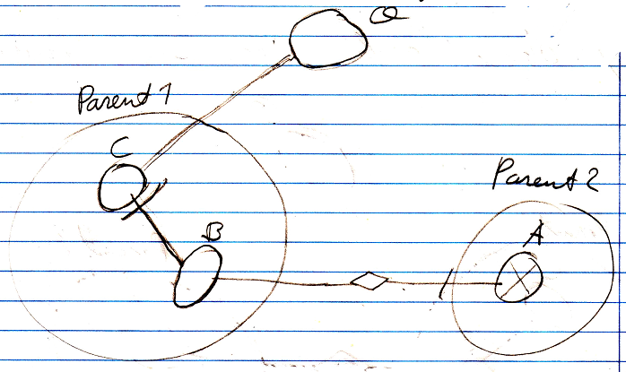

The object of symbol B will be assigned to symbol A. So then, symbol A will directly point to the object, that B indirectly points to.

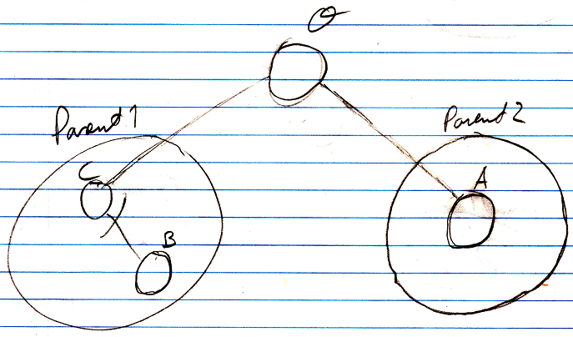

Symbol O represents the object, so symbol A after the assignment will point to symbol O, imaginarily, because it is really not pointing to an object reference, it is pointing to the object itself, that is not really visible in the diagram, but object reference O represents the object.

That represented what happens in normal object assignment.

Now the same situation is taken, but an object reference object assignment is done.

We take the same situation we started with:

An object reference object assignment looks like this:

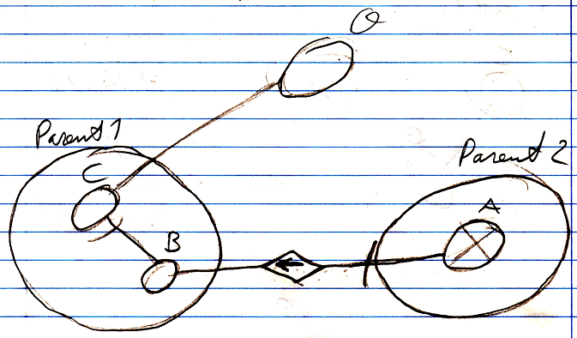

The result of the object reference object assignment is as follows:

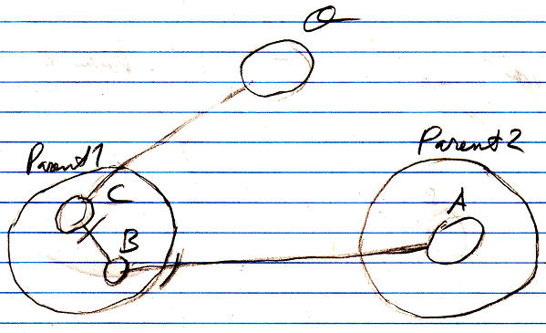

In normal object assignment, symbol A would have pointed at symbol O, that represents the object itself. After an object reference object assignment, though, object reference A points to object reference B, because an object reference has been assigned as the object target, not the object itself.

That explains the difference between normal assignment and object reference assignment.

Object Reference Assignment with Get & Set
An assignment is actually a combination of a Get and a Set call. Instead of using a call to an assignment command, you could also use a call to the Get and Set system commands. In object reference assignment, though, no Get is executed because an object reference is the diect source of the assignment, not its object.

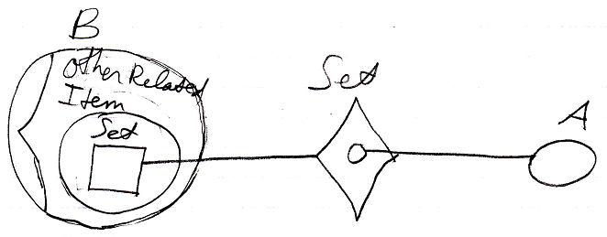

Instead of showing the objects’ system interfaces you can also show a call to a system procedure in a more basic form:

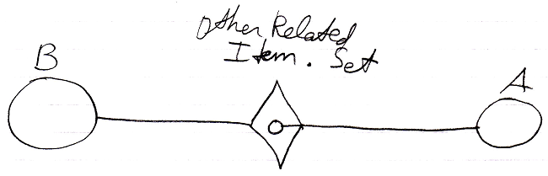

As you can see in the diagram above, system commands, just like assignment commands, also have a simpler notation than other commands.

Because it is more intuitive to use a single assignment call, instead of a Set call, and assignment is so fundamental, there are the assignment commands:

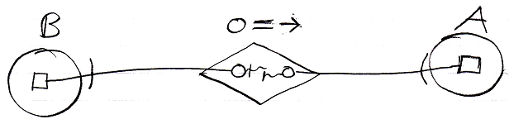

and their simple notation:

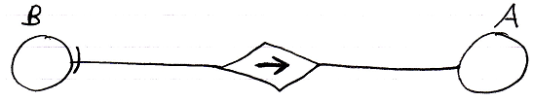

Knowing how to use Get and Set commands, instead of a single assignment call, gives you a low-level understanding of assignment. This low-level understanding is important in order to create alternative forms of assignment, as explained in the article Alternative Assignments.

See also: Assignment in a Diagram, Object Reference Assignment, Alternative Assignments

Author & Copyright: Jan-Joost van Zon Date: July 25, 2008 – July 28, 2008 Location: Oosterhout, The Netherlands Status: Finished

